Date: 18th September 2020

Mark Freeman
University of Wollongong
Northfields Avenue
Keiraville, NSW 2500

Subject: Letter of Transmittal

Dear Mr Freeman

This is our first deliverable for the financial advisory system proposal, we have provided a detailed system description and modelling report for the project. The aim of the overall project is to propose a system which can provide automated financial advice to customers based on their individual circumstances and money management advice including investment advice to those who do not have the skills to make those decisions. The system would collate all the relevant data into a discernable format, which would assist all relevant stake holders involved.

In this document we have provided a detailed analysis of all the relevant stake holders that will be involved in using the system. We have done a thorough analysis on the domain that we will be working on with our problem and all the systems that currently operate within that domain. We have provided the scenarios and personas of all the users of the system and a storyboard on how the system will be operated. The functional and nonfunctional requirements the system need to fulfill has also been stated.

Sincerely
Stephan Evtin
Adrian Lalic
Kazi Swad Abdullah
Victor Ying
Markus Tan

DAPTO Finance
System description and modelling report
Creating a System that advances access to financial services in developing countries


Executive Summary
Kazi Swad AbduLlah, Stephan evtin, adrian lalic
Victor ying & markus tan

table of contents
1. Introduction 3
2. Problem domain 4
3. Current System Evaluation 5
3.1 Apple Pay 5
3.2 Future Advisor 5
3.3 Six Park 5
4. Stakeholder Analysis 6
5. Personas 9
5.1 Persona 1 9
5.2 Persona 2 9
6. Scenarios 10
6.1 Scenario 1 10
6.2 Scenario 2 10
7. Storyboards 11
8. Initial Requirements 14
8.1 Functional Requirements 14
8.2 Non-Functional Requirements 14
9. Conclusion 16
10. References 17
11. Appendices 18
11.1 Appendix A – Project Charter 18
11.2 Appendix B – Group Contribution 19
11.3 Appendix C – Survey Questionaire 20
11.4 Appendix D – Figure and Tables 21

Introduction

One of the United Nations 17 sustainable development goals include a goal to promote sustainable industrialization, innovation, and infrastructure, specifically in the developing world. One, of the major disincentive to industrialization and innovation in developing countries is a lack of access to financial services and investment. In the today’s world, finance plays a major role, every country has its own financial system and the world economy is based on the collective financial systems of these countries.

One of the major questions we need to ask ourselves is, how can our financial systems help ordinary people? There are many financial instruments available in today’s world through which people can improve their financial situation. However, unfortunately, not everyone knows what it is and how to use it. Many people do not even have access to such tools, let alone the ability to simply control their expenses. So how do you deal with such a situation?

We would like to offer our solution to this problem., by proposing a system which would help people all around the world, to manage their money, get access to financial analysis and to build their initial investment portfolio.

We have several priorities when setting up our system. Firstly, our task is to help as many people around the world as possible, accordingly, we need to focus not only on users in developed countries but also on developing countries. In this regard, we pay attention to the interface and user experience we are trying to provide. The system should be intuitive, both for an experienced user and a novice one. Secondly, the priority of access should go to users who do not use all the instruments available in their financial markets, and people who are in the "grey zone" and do not have the opportunity to fully participate in the financial life of the country. Thirdly, the analysis of user data should help us determine the areas of growth in any given country, and that data should be relayed to the relevant government bodies, free of cost.

Problem domain

Currently, there are still 2 billion people in the world without access to regulated financial services. Despite significant progress and increased technical and financial resources dedicated to financial inclusion, there is still a lot of work left to do. It is generally believed that using a bank account can help people better manage their lives and make emergency plans. However, in developing countries, many people still do not have access to financial services and basic financial infrastructure that wealthy countries take for granted, such as savings accounts, debit or credit cards, and the payment systems on which they operate.

For many people in developing countries, the experience of obtaining financial services is very different, and these differences need to be resolved and the situation needs to be made more equitable. Each economy presents a unique pattern of customer demands. We will explore the more general challenges faced by emerging economies, and potential responses to these challenges.

Challenges usually include a series of unsuitable services provided by formal financial institutions; low institutional quality; low level of financial knowledge; and extensive financial exclusion. Common barriers to financial access in developing countries include a lack of access to financial institutions. For most banks, it is not viable to set up branches in provincial areas where request and population density are low. Clients who live in distant, underserviced zones are hence in danger of being 'avoided from the semi-formal credit market'. Furthermore, the lack of competition between financial organizations lead to the exorbitant expenses of opening and keeping up an account.

Knowledge about finance systems is likewise especially low in developing nations, for example, Pakistan, where people over 25 years, only 13% have a bank account. This is important because higher levels of education can lead to a better-quality financial products and services, as they enable better-informed customers to compare options and place competitive pressure on providers.

We hope to create a system which allows for a more inclusive financial system in developing economies: where financial products can benefit not only for individuals but also small and medium sized enterprises. Finally, we hope that in our system considers all relevant stakeholders and we design a product which is convenient not only for our target audience but also for all participants in the financial market.

Current System Evaluation

Apple Pay
The Apple Pay system has indirectly assisted in shifting users into the cashless world. Cashless transactions have grown exponentially in today’s world. In doing so a more secure, transparent, and accountable financial system exists today, which appeals to consumers of all levels of wealth. Innovators, such as Apple can automate manual processes such as money management, which can be quite taxing on individual and business alike. Instead, businesses and clients can eliminate wasted time and can focus on more constructive and productive efforts. On a national scale this type of seemingly ordinary technological innovation can severely reduce nonproductivity, leading to a boost in the economic performance of a country. Financial institutions reward their clients by liberating them from traditional payment methods and make cashless payment methods easier to access.

Future Advisor
Financial advisory systems such as Future Advisor lay the steppingstones towards financial automation and industry growth. The platform offers free financial consultation using sophisticated algorithms to recognize potential areas of positive economic performance. Incidentally, such a method would also incite a boost in economics activity since it influences investors to invest in those targeted areas. These automated advisors provide full consultation on managing assets, investment advice and assist in minimizing taxation. As a result, a whole class of younger, fewer wealthy individuals are receiving free financial services even with the lack of experience they possess. The best part about this system is that its globally accessible from any location where internet is available. Figure 1 in the appendix depicts the 6 integrated areas of financial innovation.

Six Park
Robo-Investment systems like that of SIX Park provided a convenient way for users with limited knowledge on financial markets to access expert advice on investments and create their own investment portfolio or expand on an existing one. These systems are significantly cheaper than human advisors as they are a program that follows standard algorithms and have no labor cost associated with them. The algorithm takes into consideration aspects such as the users after tax income, expenses, and existing assets as well as liabilities. These systems are suitable for aspiring investors with little to no financial knowledge working in a noncompetitive environment. A typical process for registering for a robot advisor is shown in Figure 2 in the appendix.

Stakeholder Analysis

USERS

PRIMARY
Stakeholder | Interest | Influence | Expectations | Risks
SME’s | High | Medium | Small to medium sized enterprises which also include businesses such as cafes etc. expect the system to provide an increase to financial income and money management. | The new system would require continuous internet access which can be an issue at least developing countries.
Customers | Medium | Medium | The customers expect that the system will provide an easily accessible financial advisory system and a portal to invest their money. | In developing countries, people may not be able to access the technology required to integrate it into their regular lives.

SECONDARY
Upper Management | Medium | High | Upper management include the Board of Directors for these SME’s. They should expect the system to provide a reduction in company expenses | It’s a big modification to operations for a business so some business owners may be hesitant to change a system that is already deemed successful.

TERTIARY
Researchers | High | Low | Researchers will use this new technology to assess the changes that the new system brings to the society. They expect the system to provide financial data to researchers which they can use to track areas that are developing. | The risk is that it would take years for reliable data to be presentable.

NON-USERS

Banks | High | High | The banks have high interest in the system as they are needed to supply the payment systems. It is expected that they will require a subscription-like contract with the SME’s if they look to use the systems. | For the banks, it can be seen to be a win- win situation as they will be getting paid for solely supplying the system. However, it is an investment from the banks to provide the service, so if the system fails in a country, the banks my see the investment at a loss.
Government | Medium | High | The system aims to increase spending in a country which would ultimately result in a greater economy for a developing country. Governments expect the new system to provide a better financial cycle within the country as they will be able to raise the tax on goods and services if they choose to. | There are currently no forecasted risks for Governments regarding the new system. However, it could be seen that if they raise tax due to the new system, businesses may raise the price on goods which may discourage spending.
Industry Competitors | High | Medium | Competitors are expected to assess the performance of the system before they implement it into their own operations. Depending on its success, with more competitors accessing the system, it would create a universal financial system throughout the country, thus helping the growth of the country economy. | As it would take a long time for data on the effectiveness of the new system to be available, competitors may be hesitant to integrate it straight away.
Suppliers | Low | Low | With digital transactions, suppliers will get their payments from businesses through more secure and efficient methods. Payments will be easier to track which will speed up the logistics of their operations. | Suppliers may not feel like transitioning to the new system is necessary which may result in a breakdown between supplier and business.
As part of the systems analysis process, we have identified 8 different stakeholders that are relevant to this project, these stake holders can be broken down into two subgroups, users, and non-users. Users are the groups of people who will be directly using this application and non-user will not, however they will be directly affected by it. We have shown the complete list of stake holders together with their expectations of the system in the table above.
For the sake of our project we have decided to only consider the expectations of the direct users of our system. We have analyzed the influence and impact of the stakeholders involved (i.e. users) and have concluded that the stakeholders most relevant to our project are:
- Direct Customers: this could be working professionals, retirees or anyone with an income or assets.
- SME Management: this could be anyone who is directly in charge of making decisions in a company.
To better understand the needs of the user who will be using the system, we have organized an online survey of the two groups mentioned above. These include 100 SME’s and 100 direct customers based in over 3 countries, these countries include Bangladesh, Kazakhstan, and Ghana. We reached the prospective user over their Facebook and LinkedIn profiles and asked them respectfully, to assist us in our survey.
We developed a questionnaire for each group of stakeholders asking them relevant questions regarding the requirements of the system from their end. We asked largely opened paragraph styled questions so that we can gauge the user’s preferences are. We based our questions on the prior research and our own critical though process. The two sets of questionnaires are attached to the appendices.
From the survey we can conclude that access to financial services is a major issue in all these countries. The major reason businesses and customers in these countries are unwilling to access financial services include high cost, lack of availability, perception of bias and corruption. When it comes to businesses the financial service that is most required is money management, a lot of small business cannot afford to hire staff specifically to assist in financial matters and so an application that can assist with that would greatly help this businesses. When it comes to individuals the financial service that is most required is an investment portal that provides sound financial advice on investing their money and through which they can invest their money directly. Individuals regularly said that they did not have a background in finance to make those kind of investment decisions. Businesses are looking for a system that provides sound advice that is fair and unbiased, which is easy to understand and easy to implement. Similarly, individuals are looking for investment advice that is affordable, unbiased and fair and leads to a sustainable second income for them and their families..

Personas

5.1 Persona 1
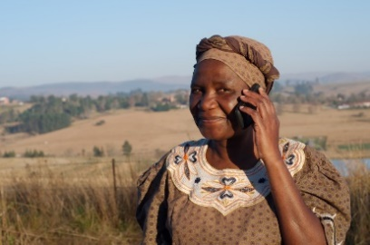 | Name: ANNE AdAnya  Age: 45  Nationality: Ghana  Education: Bachelor’s in computer science  Occupation: IT Consultant  Details: Anne is an IT Consultant working for a large multinational company based in Ghana, she has expert knowledge in programming, however, lacks a background in investment. She has some money saved up and would like to invest it.

Anne has been working as an IT Consultant in Ghana for the past 15 years, during this time she has lived very frugally and set aside some money each year to invest in something that can provide a second income for her and her family. She finally has enough to make a substantial investment into something, however she lacks the financial knowledge to make that decision. In here country there is extreme corruption and fraud is rampant and she does not trust any of the financial advisor there. She needs advice that his accurate and unbiased that can help her sustainably invest her hard-earned savings.

5.2 Persona 2
 | Name: Victor AzeRban  Age: 62  Nationality: Kazakhstan  Education: 8th Grade  Occupation: Store Owner  Details: Victor is an independent business owner who owns a small grocery store in Kazakhstan. Recently he has be experiencing some difficulties in is business mainly due to money management issues and a lack of financial advice.

Victor owns a small grocery store in Kazakhstan and until recently he had no problem making ends meet. However, due to current situation with COVID 19, business has really fallen of a cliff. He believes that the main reason his business is not doing so well is because of poor money management and excess expenses. He needs financial advice that can help him make his business more financially viable. However, in his country this kind of advice is either not readily available or is too expensive. Furthermore, Victor lacks a formal education and believes that he will not understand the complex advice that these advisors might give him. He needs financial advice that is easy to understand and at an affordable price.

Scenarios

6.1 Scenario 1
One day, Anne was going through her finances, and the savings account that she had been carefully nesting for the past 15 years was finally large enough for her to make a substantial investment into something. However, Anne dis not have the background in finance to do that. She decided to use an online application to help her make that investment decision, as it was the best option available to her. She set up a personal profile on the site, and then uploaded her financial information which includes her taxable income, expenses, and existing assets as well as all liabilities. After that step was done, the system provided her a list of investment portfolios specifically tailored for her. She went through the list and specifically found the ones that she wanted to invest in. After that, she entered her banking details into the system so that then money can be deducted from her account and the investment can be finalized.

6.2 Scenario 2
One day, Victor was managing his business accounts, which he has been doing for many years now and realized that he has not made a profit in the past six months. He believes that reason he has not been making a profit is because of excess expenses in relation to his revenue. He also believes that the business needs to be scaled back, and he requires financial advice on how to do that. He decides to use and online application, which has been recommended to him by his peers. He opens a personal account and then provides his financial details into the system. He also provides additional operational information that can then be used in the financial advice that the system will provide. The system automatically provides a list of recommendations to reduce his expenses and make his business more viable. The recommendations provided are written very clearly and without unnecessary jargon. The system also provides money management options to Victor so that he can reduce the hassle of paying expenses and automate the process of payment. This will help victor keep better track of his expenses.

Storyboards
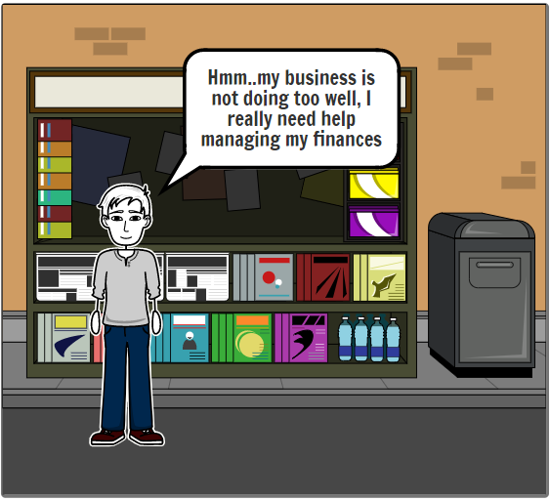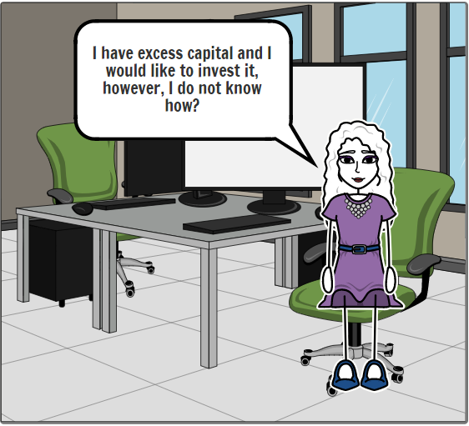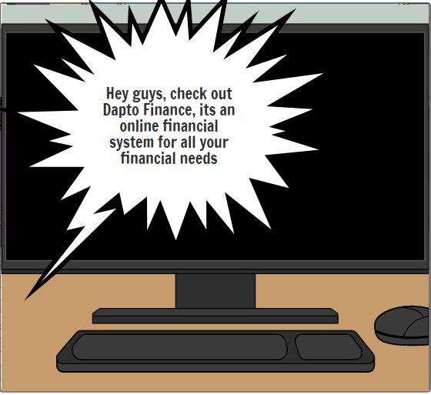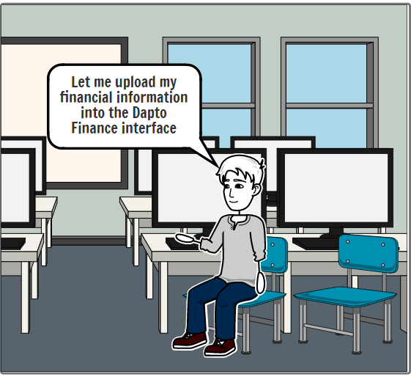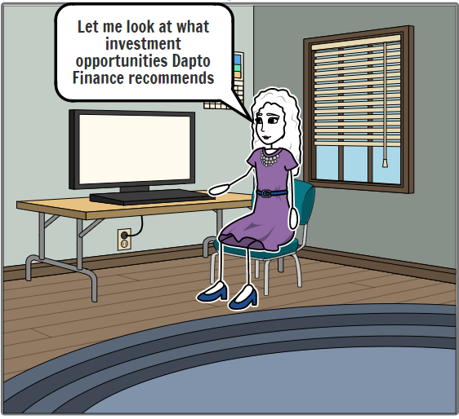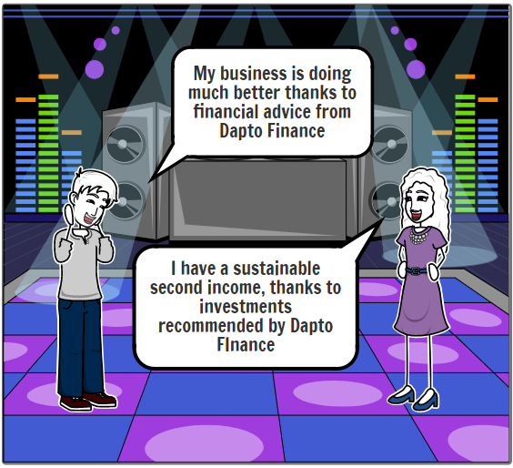

Initial Requirements

Functional Requirements
The system has three major functions that it must carry out to serve the users.
- Provide automated financial advice based on information provided by the user. The financial advice must be catered to the user’s individual needs and must be explained in such a way that it is easily understood by the user.
- Provide investment advice based on the client’s individual circumstances and their current investment portfolio. The system should be allowed for the user transfer money from the user’s bank account directly to the investment opportunity.
- Provide a money management portal where the user can set up payment schedule for all their weekly and monthly expense as well as keep track of all income from salary and/or investments. The portal should provide the user with a weekly/monthly report on the accumulated date on all financial transaction during this time.

8.2 Non-Functional Requirements

8.2.1 Usability Requirements
The application needs to have an easy to use user interface. A user-friendly interface is vital to bringing in more traffic to our system. As the targeted demographic is based in a developing country, who do not necessarily have the skills or literacy required to operate an ambiguous system, it is important for the system to have a user-friendly interface.
Having an easy to learn user interface, is critical and can lead to a better experience and increase user retention. It is important, that the system does not impose a heavy memory load on the user when operating the system. The user must be able to pick up functionalities of the system based on their affordance; this will help them familiarize themselves with the system much more easily on each successive visit.
Error checking is another aspect of the usability requirement that needs to be taken into consideration. There should also be frequent auto corrections in the system, as the user is likely to make multiple mistakes. Furthermore, error messages that result from a mistake should be precise and tell the user exactly what needs to be rectified.

8.2.2 Reliability Requirements
The application needs to be accurate in terms of the information that is available on it, errors need to be easily recoverable and the system needs to be readily available to the user at all time. The system needs to be reliable, as consistency is important to attract and retain users.
The system needs to be tolerant of user errors, as the targeted demographic is likely to make multiple mistakes and therefore it is essential that the system allows for the user to go back to a previous section and edit their mistakes, whenever possible.
The system always needs to be reliable, as the targeted location where the system will be used does not have a reliable or fast internet connection. The system must utilize browser cookies to store information if the internet connection drops off. The system should be calibrated to function with a low bandwidth internet connection.

8.2.3 Performance Requirements
The application needs to perform at a high standard under all circumstances. The system must therefore perform at a high standard, regardless of whatever location the system is accessed from or whatever time zone the system is accessed in. A high performing system will lead to a greater retention of users and provide for a greater user experience.
Our system is likely to be used in various countries, with various degrees of communication infrastructures, therefore the system needs to be calibrated to perform well in all locations. Whenever, the performance drops, on-site or off-site technicians should be available to assist in the matter and bring the system up to speed.
Our system is likely to be used in various countries, with various time zones, therefore the system needs to be calibrated to perform well regardless of the time. Dedicated, servers should be located at those locations to host the system and provide consistent performance 24 hours a day 365 days a year.

8.2.5 Supportability Requirements
The application needs to be maintainable and compatible under all circumstances. The system must therefore be easy to maintain and should also be compatible with various hardware and software requirements. A supportable system would mean that it is accessible to a wide range of people and therefore a much wider user base.
Our system is most likely going to be based in various countries with different language and technical skill levels. Therefore, the system should be a simple one which is open source, that the user can adapt to his/her own circumstance.
The system should also be multi-platform, which means that it should be able to operate on a wide range of operating system with varying hardware configurations.

Conclusion
Our project can be characterized as a fintech service. We think that combining the necessary functionality and a user-friendly interface is the main task of any B2B and B2C system.

Summing up, we would like to note the following: fintech services have come a long way not only in terms of functionality but also in interface design. The project presented by us should be useful and useful for everyone. Human-friendly design principles should be applied in a fast-paced and vital field like fintech.

References

United Nations Sustainable Development. 2020. Infrastructure And Industrialization. [online] Available at: <https://www.un.org/sustainabledevelopment/infrastructure-industrialization/> [Accessed 13 September 2020].
Zeller, A., 2020. Credit Card Logo For Personal Finance App. [online] Dribbble. Available at: <https://dribbble.com/shots/7038085-Credit-card-logo-for-personal-finance-app> [Accessed 13 September 2020].
Kimber, M., 2020. How To Get Started Investing With A Robo-Advisor | Canstar. [online] Canstar.com.au. Available at: <https://www.canstar.com.au/investor-hub/start-investing-robo-advisor/> [Accessed 17 September 2020].
Six Park. 2020. World-Class Investment Management And Proven Strategies | Six Park. [online] Available at: <https://www.sixpark.com.au/> [Accessed 17 September 2020].
Buckley, R.P. and Webster, S., 2016. FinTech in developing countries: charting new customer journeys. Journal of Financial Transformation, 44.
Grandolini, G., 2015. Five challenges prevent financial access for people in developing countries. The World Bank IBRD-IDA. Retrieved March, 20, p.2017.

Appendices

12.1 Appendix A – Project Charter
Directions
Groups work better when members have a common understanding of the group’s goals and the ground rules for group activities. The purpose of this exercise is to help your group set some ground rules and goals.
Each member of your group will have some idea how the group should operate. This is the opportunity to share your thoughts so “simple misunderstandings” are less likely to arise in the future.

PROJECT NAME: Creating a System That Advances Access to Financial Services in Developing Countries
Our ground rules
- Our team will meet every Sunday at 7pm on WebEx
- Our team will use WebEx for meeting, discord for messaging and one drive as a cloud storage
- The meeting should be no more than one hour
- It is okay to miss a meeting, but with a valid excuse
- If one misses a meeting, they should let everyone know on discord.
- Lateness is not recommended.
- If some has not contributed, it will be mentioned in the group contribution form in the appendix.
- Discussion should be made on WebEx and Discord
- If a group members work does not meet our standards, we need to collectively fix it.

Our goals
- Our team is aiming to finish this project in due time and within scope
- We are aiming to get an HD in the project and the course overall

12.2 Appendix B – Group Contribution
Name | Contribution to Group Project
Kazi Swad Abdullah | Storyboards  Initial Requirements  Personas  Scenarios
Adrian Lalic | Current Systems Analysis
Markus Tan | Problem Domain
Victor Ying | Executive Summary  Stakeholder Analysis
Stephan Evtin | Introduction  Conclusion

12.3 Appendix C – Survey Questionaire
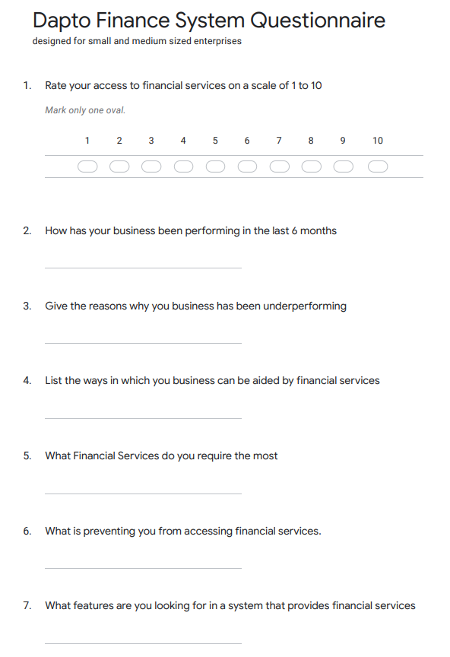

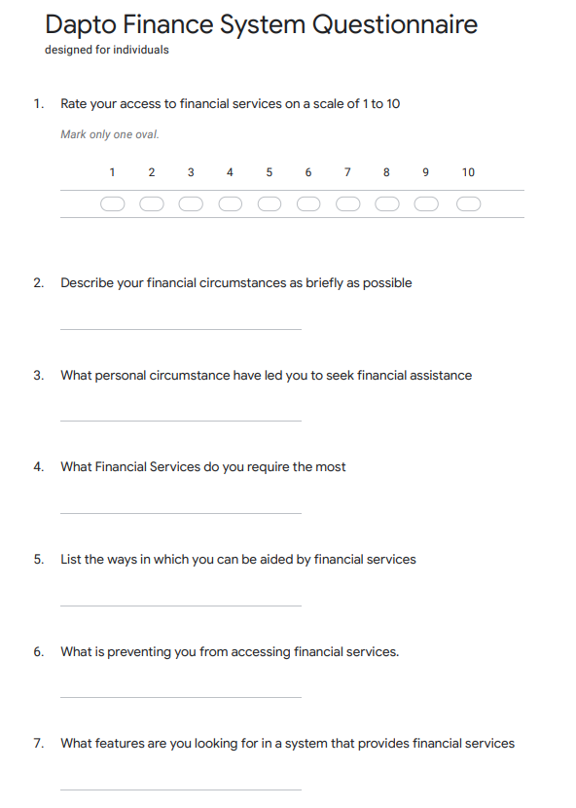

12.4 Appendix D – Figure and Tables
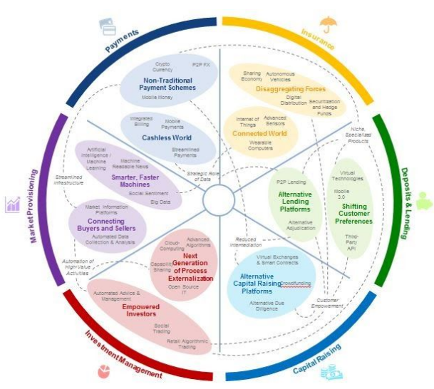
Figure 1. SOURCE: Jesse McWaters, Project Manager Center for Global Industries, World Economic Forum (June 30, 2015)
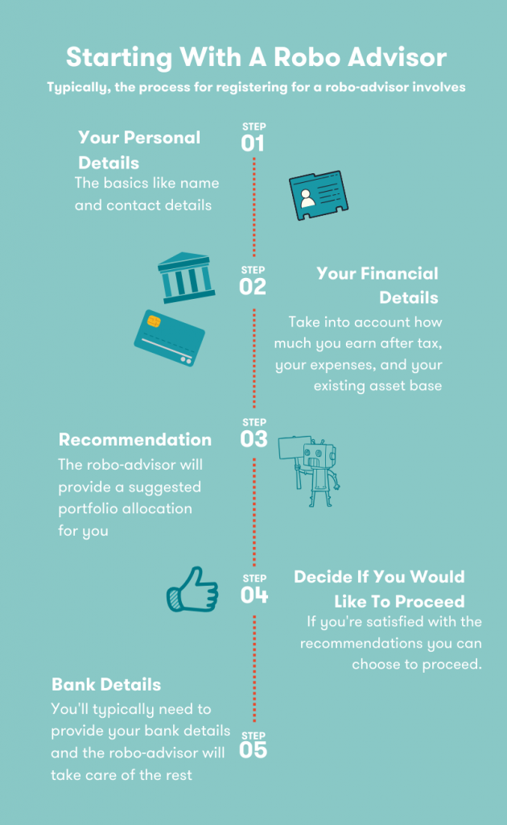
Figure 2. SOURCE: Madeleine Kimber, How Do I Start Investing with a Robo-Advisor, CANSTAR – Investor hub (February 12, 2020)

